**VPC 18th September 2024**

Create VPC in Ipv4 CIDR – 10.0.0.0/16

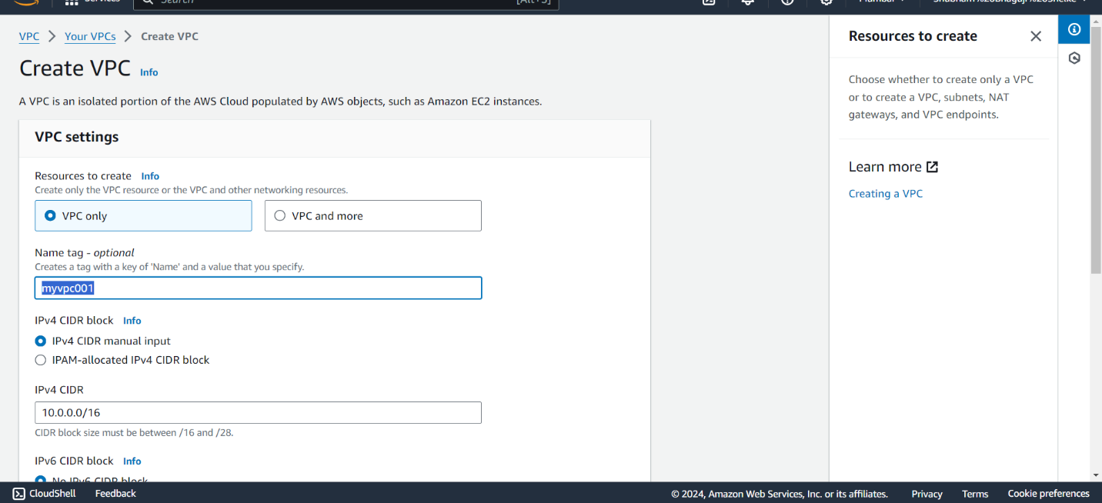

Create Subnet (Public Subnet) ipv4 CIDR – 10.0.1.0/27

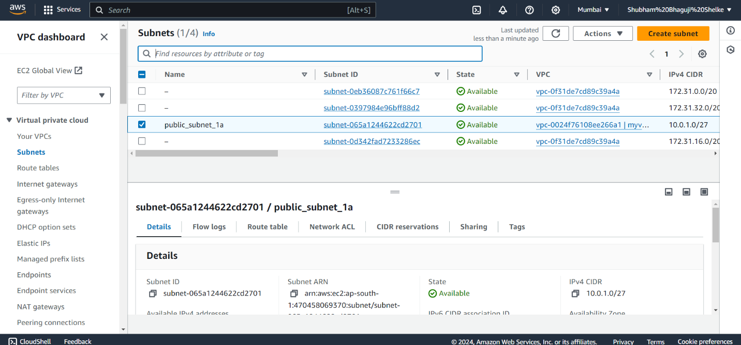

Create Subnet (Private Subnet) ipv4 CIDR – 10.0.2.0/27

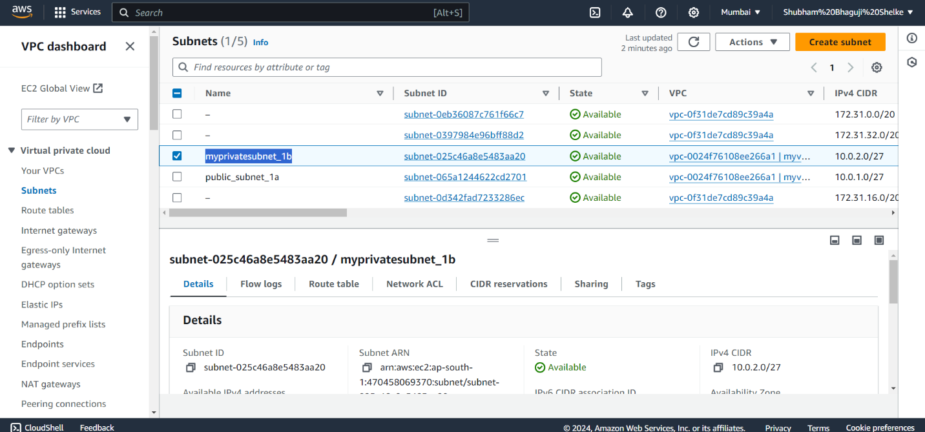

Create Internet Gateway 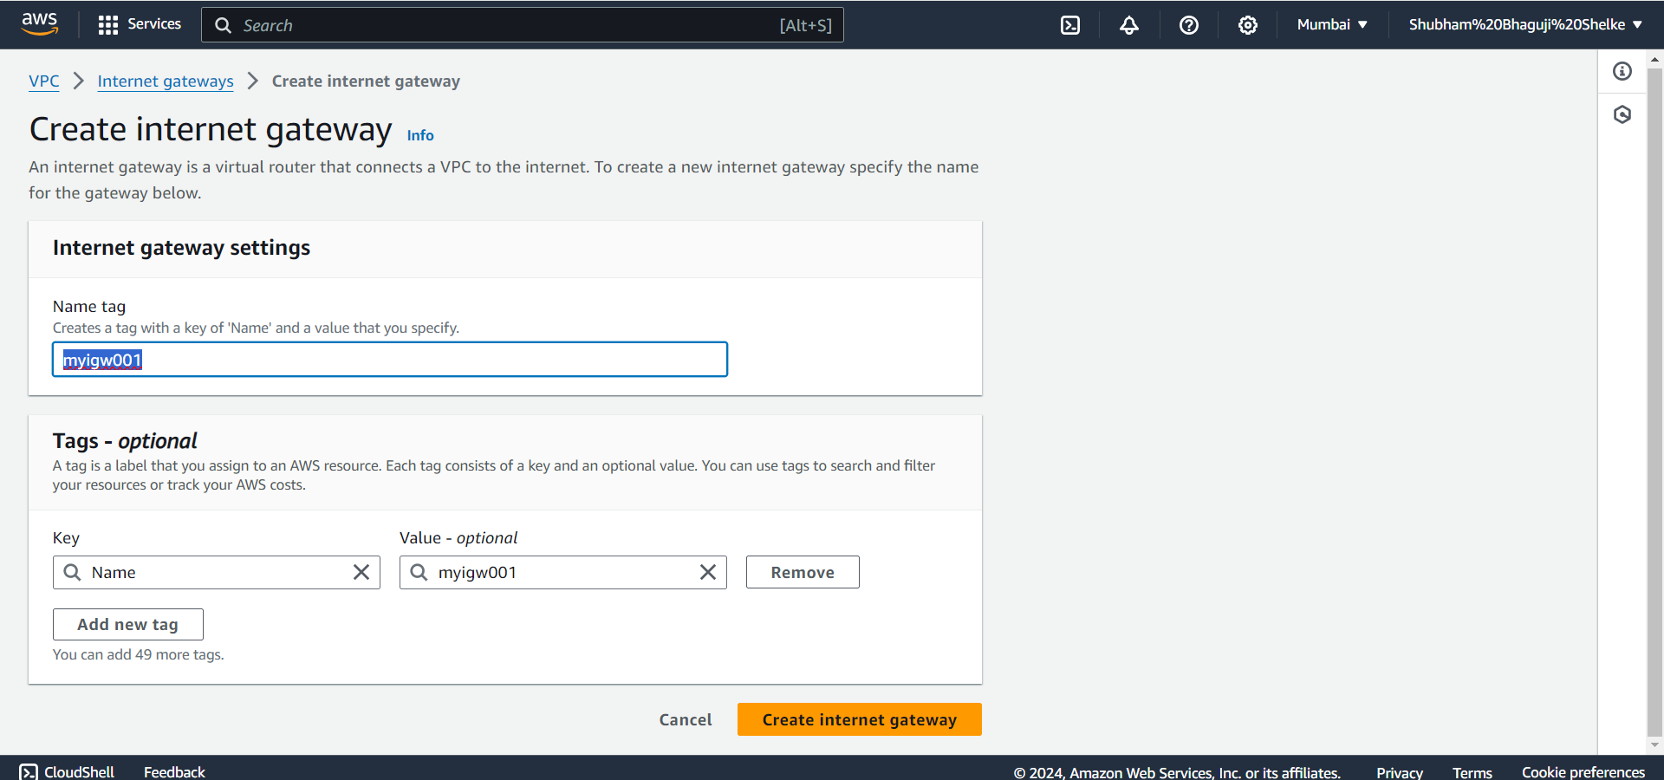

Internet Gateway are attached to VPC

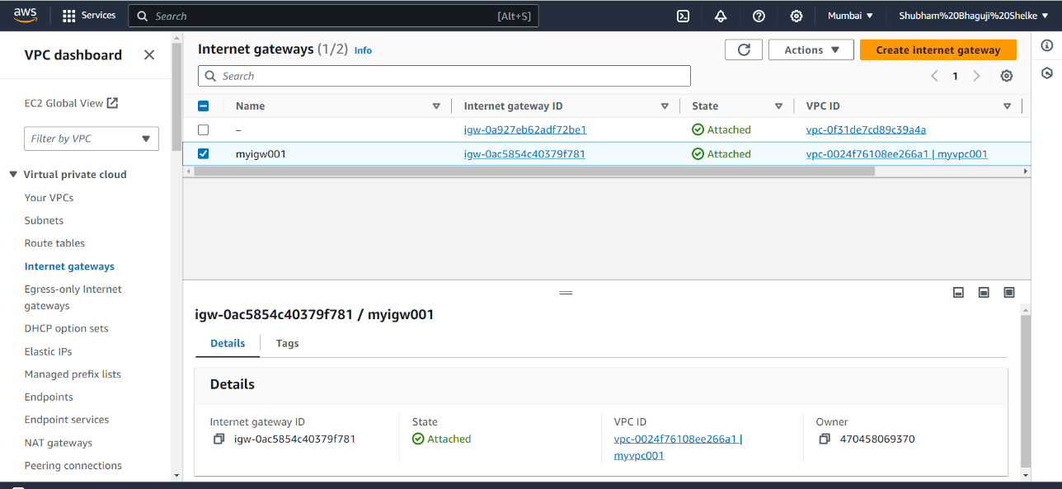

Create Route Table (public_route_table)

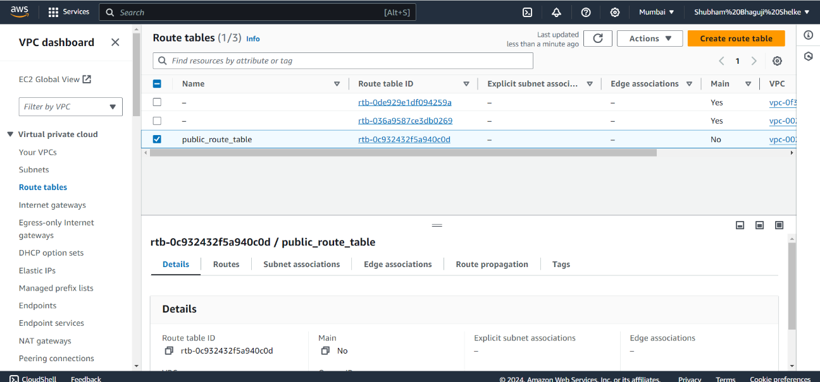

Create Route Table (private_route_table)

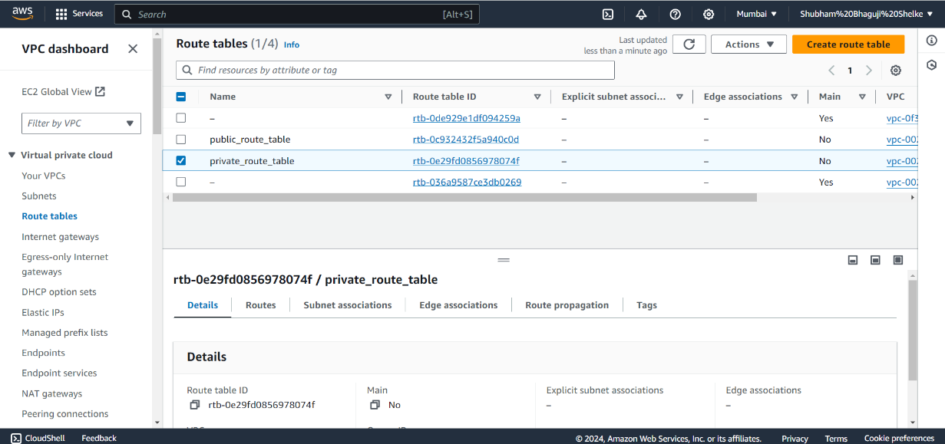

Public route table and update add route (0.0.0.0/0) in internet gateway

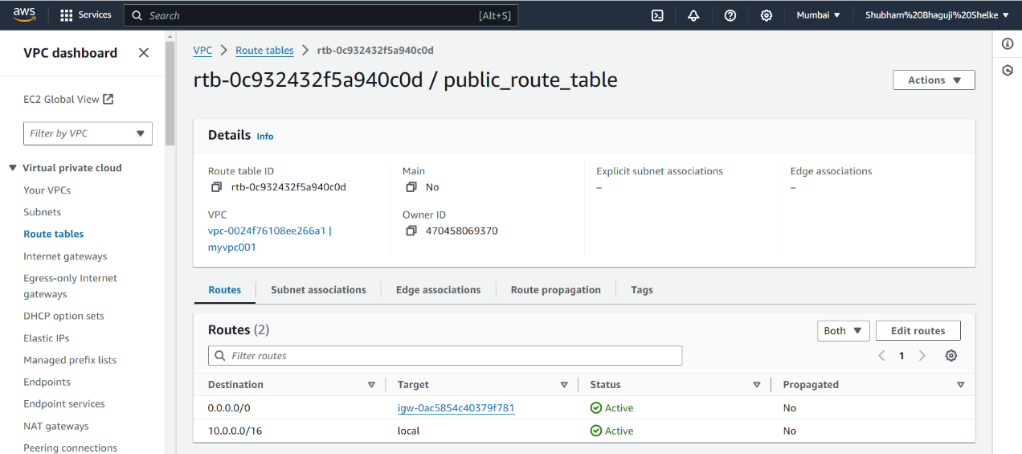

Create NAT (Network Access Translation) in Public Subnet with allocate EIP

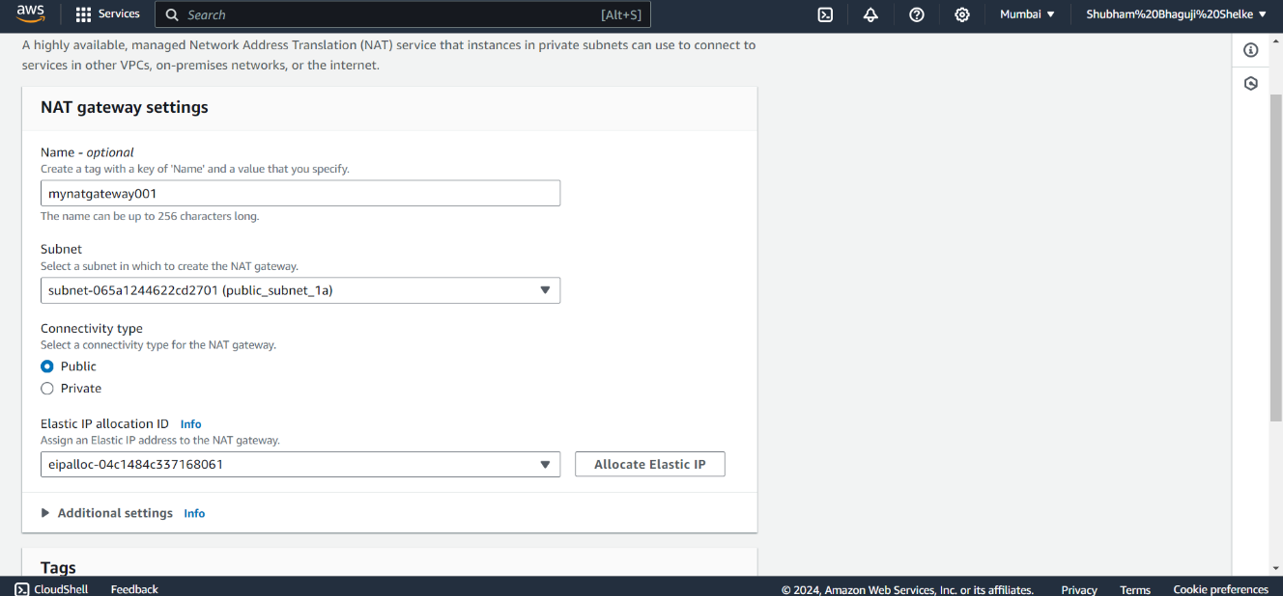k

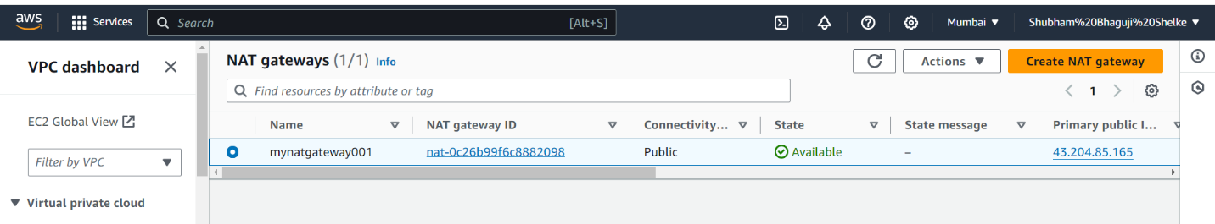

Private route table and update add route (0.0.0.0/0) in internet gateway

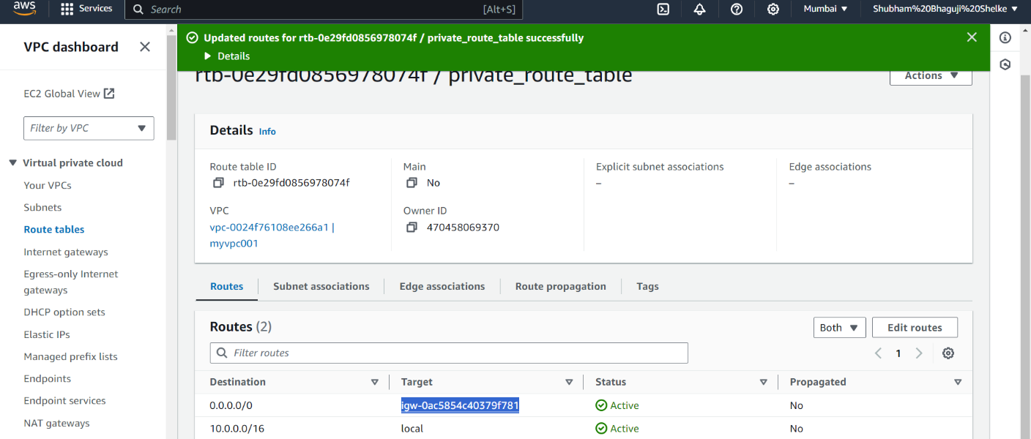

Private subnet association

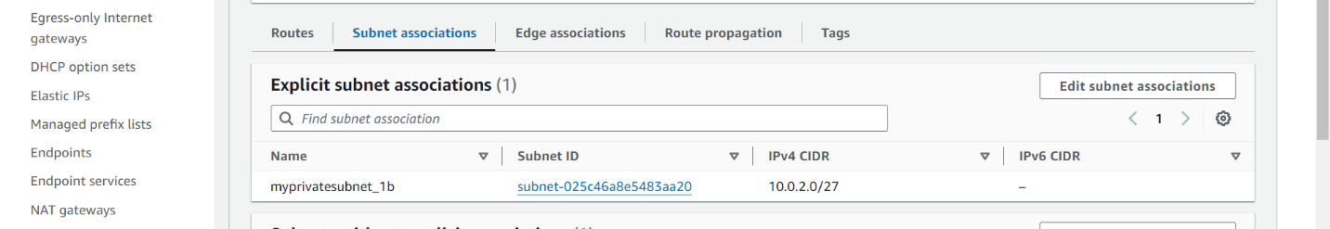

Subnet are Private to Public

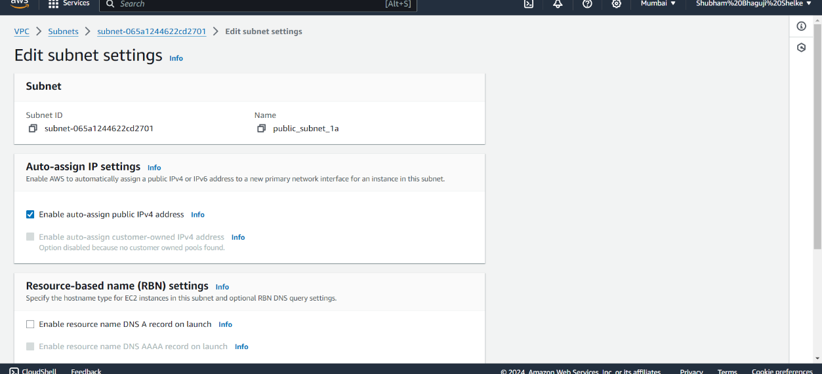

Check this Public Subnet in – Public or Private IP & Check this Private Subnet in – Private IP

1. Create ec2 instance in (node01_public_subnet) in 1a

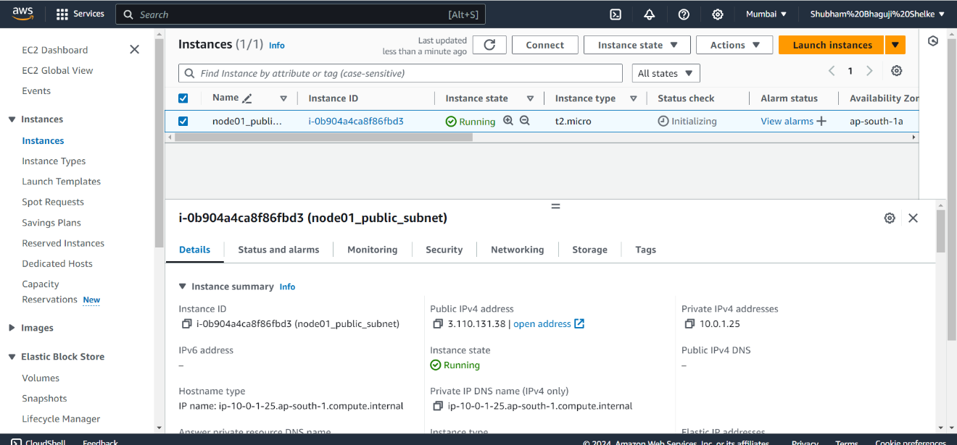

1. Create ec2 instance in (node02_private_subnet)

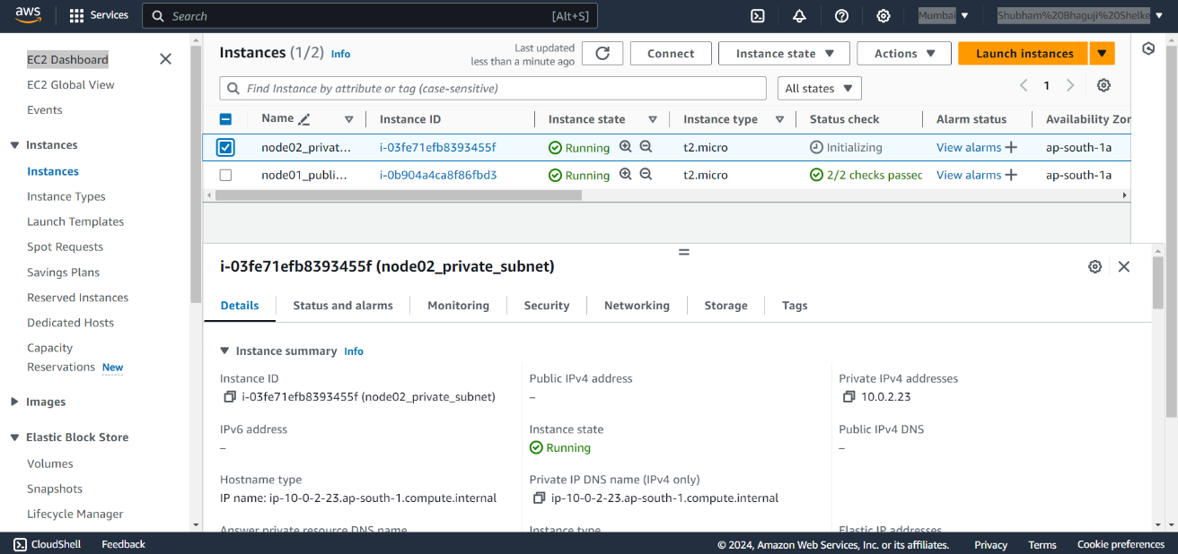

Check internet connectivity in public subnet

Check for private subnet in private IP